Word | Definition in YOUR own words | Picture to help you remember
Chapter 19  Medicines | Things that treat or prevent diseases | 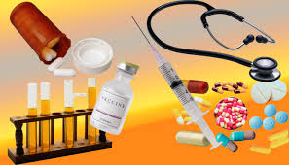
Drugs

Vaccines

Side Effects | Reaction to medicines (unwanted) | 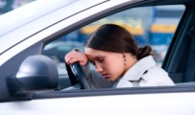  Zzzzzzzzzzzzzz (drowsiness)
Additive Interaction

Synergistic Effect

Antagonistic Interaction

Tolerance

Withdrawal

Word | Definition and Sentence | Picture
Prescription

Over the Counter Drugs

Medicine/Drug Misuse

Medicine/Drug Abuse

Drug Overdose

Addictive Drug

Chapter 20
Nicotine

Stimulant | A drug that stimulates your heart, nervous system and other major body parts | 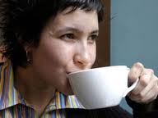  Coffee is example
Smokeless Tobacco

Chapter 21
Ethanol

Word | Definition and Sentence | Picture to help you remember
Fermentation

Depressant

Intoxication

Factors that influence alcohol’s Effects

Short Term Effects of Alcohol

Long Term Effects of Alcohol

Binge Drinking

Alcohol Poisoning (See BAC Chart)

Psychological vs. Physiological Dependence

Word | Definition and Sentence | Picture to help you remember
Alcoholism

BAC- Blood Alcohol Concentration

Alcoholic

Recovery/Sobriety

Chapter 22
Substance Abuse

Illegal Drugs

Illicit Drug Use

Overdose

Addiction

Paranoia

Word | Definition and Sentence | Picture to help you remember
Marijuana

Inhalants

Anabolic Steroids

Psycho-active Drugs

Hallucinogens

Designer Drugs

Euphoria

Opiates

Rehab

Drug Free School Zones and Drug Watches

