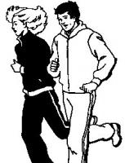

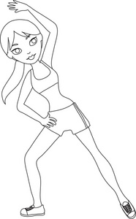
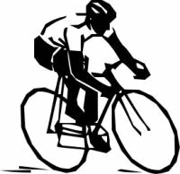

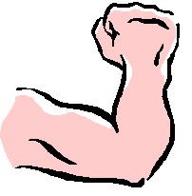

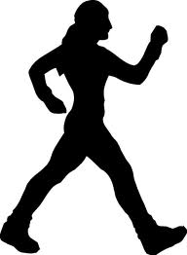

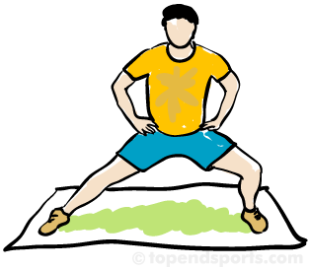

5-10 minutes
Slowly move muscles that will be used. Raise heart rate.
(Ex: jogging)

5-10 minutes
Stretching major muscles that will be used.

20-30 minutes
Exercise in your target heart rate zone
(Ex: Biking/Cycling)

30-45 minutes
Do strength endurance exercises.
(Ex: Weight lifting)

5-10 minutes
Move muscles used in workout at a reduced pace.
(Ex: Walking)

5-10 minutes
Stretch muscles that were used.
(Ex: Stretching major muscles)

- ______________

- ______________

- ______________

- ______________

- ______________

- ______________

